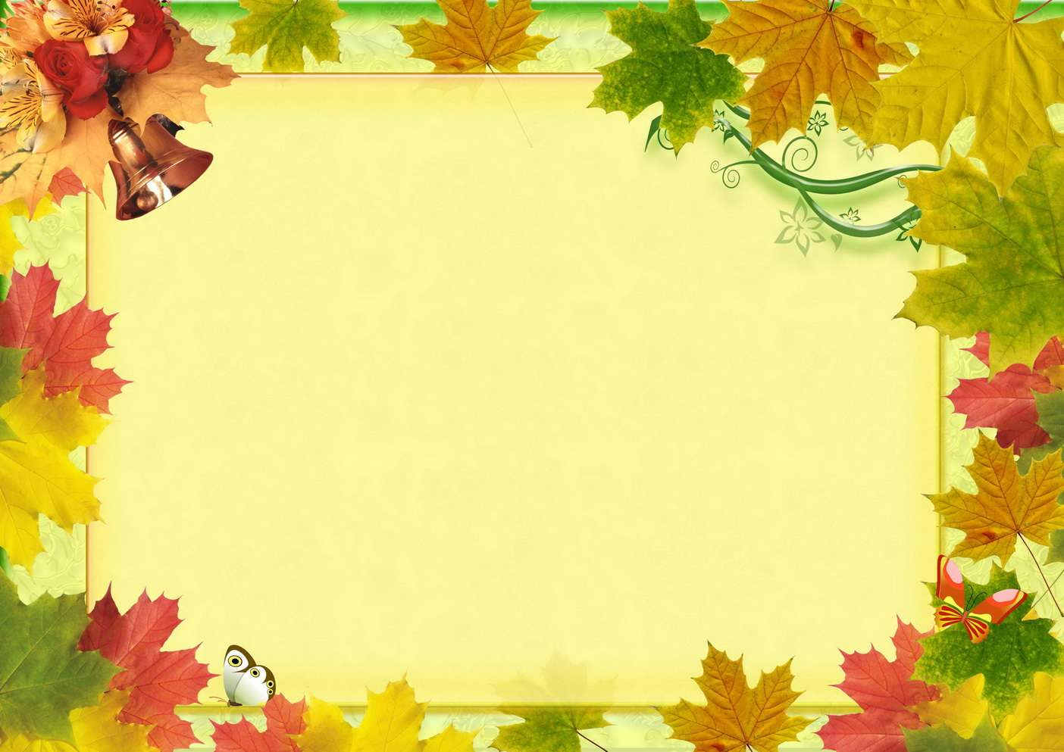

|  |  |  |
| --- | --- | --- |
| **Понедельник** | **Вторник** | **Среда** |
|  |  |  |
|  |  |  |
|  |  |  |
|  |  |  |
|  |  |  |
|  |  |  |
|  |  |  |
|  |  |  |
|  |  |  |
| **Четверг** | **Пятница** | **Суббота** |
|  |  |  |
|  |  |  |
|  |  |  |
|  |  |  |
|  |  |  |
|  |  |  |
|  |  |  |
|  |  |  |